MADE IN NOTTINGHAM
Presidents Fund Newsletter No 8 September 2018
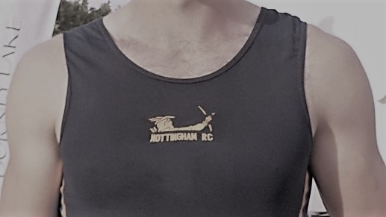
World Championships Finalists
Anna and Grace

World Under 23 Medalists
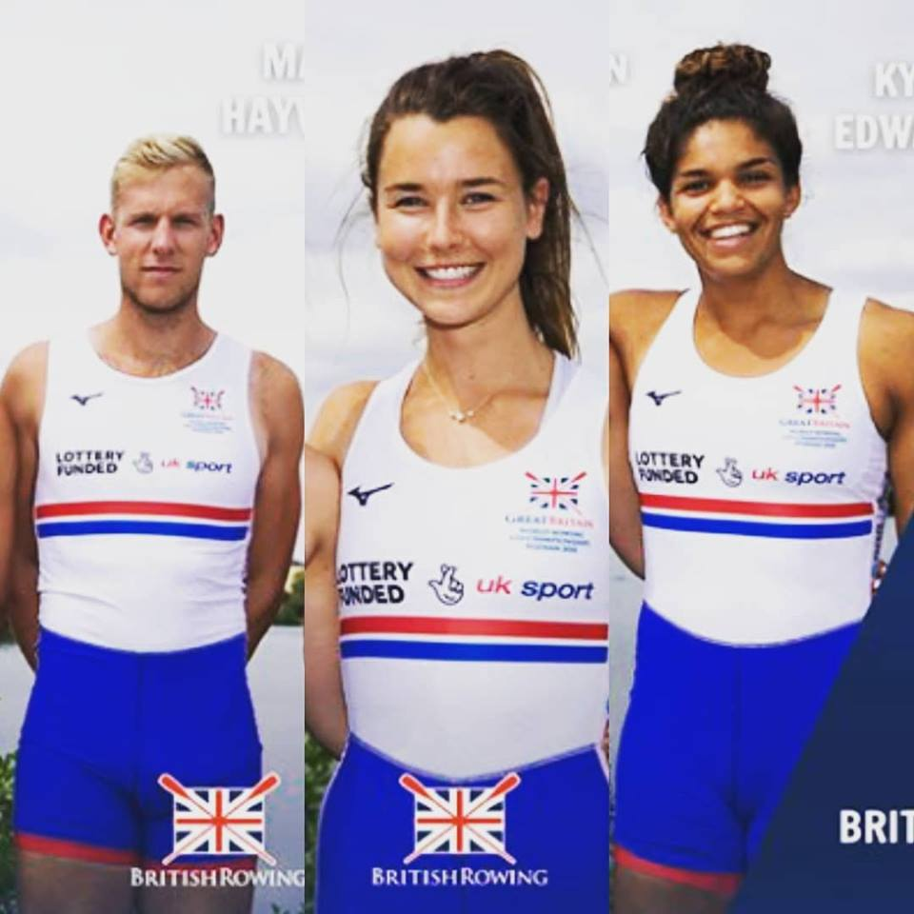
Matt Anna and Kyra

World Rowing Championships
Plovdiv, Bulgaria
Grace on her way to another gold.
Grace’s PR3 mixed four qualified for the A final with a 3 length win over France & Australia. In the final, USA blasted out of the blocks but could only establish a slight lead over the British Four. The two crews slugged it out over the 2,000 metre course however the British crew’s race to the line proved to be too much for the USA four who were half a length down crossing the line.
Grace remains undefeated! Another fine result for her and made all the more impressive as the crew had not raced very much this year due to injuries. The Great Britain team has won this event at every competition since 2010 and Grace has been in the boat since 2014.

Anna in action
Anna has had a fanastic season culminating in 4th place in the Womens’ Double sculls. Anna came back from Washington University for the summer break and teamed up with Charlotte to win at Henley Royal regatta and the World under 23 Championships. The selectors were so impressed with their boat speed that they were selected for the Senior Championships. This had not been on the girls radar so they raced with a sense of freedom and felt that it would be good experience. They won their heat in the second fastest time of the day. The semi-final was a close race with ony 4 seconds covering the whole field. They managed to come in third after a photo finish with Poland. The times for the 6 crews in the final were all within a 4 second range, promising an exciting race. Unfortuantely the lanes were reallocated as the racing commission deemed the course to be unfair. This meant Anna and Charlotte were now drawn in one of the unfavoured lanes. They responded to this and were lying second at halfway. However the older and more experienced crews slipped past them but they still finished fourth.
Their performance was the best of the British Womens’ Olympic squad.
Henley Royal Regatta
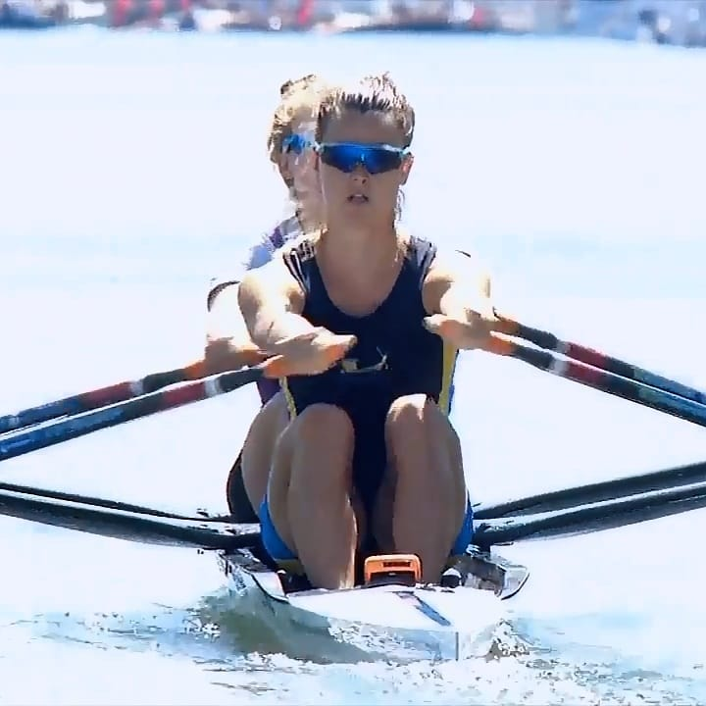
Anna Thornton and Charlotte Hodgkins-Byrne were the stand out crew in the Stonor Challenge Cup for Womens’ Double sculls at Henley Royal Regatta. In the final they smashed the existing course records to the Barrier and Fawley which had been set by the New Zealand World Championship double in 2017.
Anna has become the first woman at the club to win at the “mens” Henley Royal Regatta.
Matt Haywood stroked the Under 23 quadruple scull in the Prince of Wales Challenge cup. They progressed through to the final where they came up against a strong Dutch crew who managed to slowly get a length’s lead but could not get away from the British boat.

Home Countries Regatta
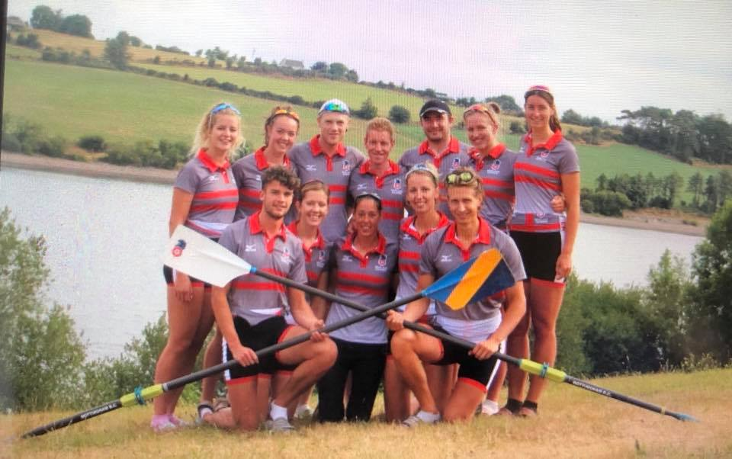

After a successful trial at the London Docklands, 10 rowers, a cox and a coach were all selected to represent England and travelled to Cork for the annual Home International Regatta taking place at the National Rowing Centre, Home of Rowing Ireland.
The mens’ and womens’ coxed fours were the first to race coming home in 4th and 3rd place respectively in some closely fought racing. Next up were the double scull of Annie and Sophie. After a strong season these girls went out hard to ensure they secured the gold medal, which they did in style, finishing 2 lengths clear of an attacking Irish crew.
The duo then raced again in the quadruple scull, joined by athletes from Norwich and Peterborough where they held the lead at the 1000 metres but were passed by the Irish with 750m to go but held on for second place.
The penultimate race of the day was the womens’ eight, coxed by Fergus, with the womens’ coxed four being joined by athletes from Vesta and Tideway Scullers. With England trailing by 1 point in the womens’ team trophy there was everything to play for. The girls stormed their race to win by over a length having led from the start, and securing the team trophy in the process.
Womens’ Double Scull: Annie Campbell-Orde and Sophie Connolly - GOLD
Womens’ Coxed four and eight: Fergus (cox) Rachel Borrows, Kate Parsons, Fleur Tavare, Lucy Holgate GOLD in eight
Mens’ Coxed four: James Doleman, Steve Bennett, James Walker, Ben Farrell
Coach Nikki Spencer

Junior National Championships
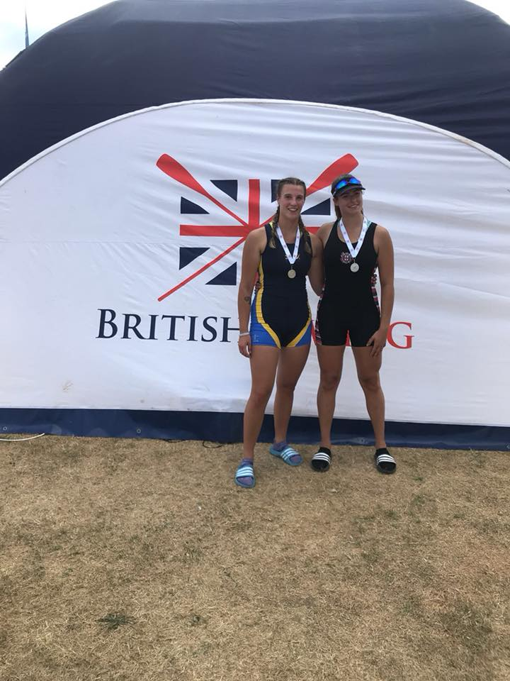
Jenna Draycott finished her junior rowing career on a high winning a silver medal in the Womens’ Junior Double Sculls with Megan Duthart from Thames RC after a battle the whole way down the track, missing out on the gold by just over 1 second She is now off to Ohio State University in USA.
Lucy Holgate is also off to UCLA on a rowing scholarship joining Kyra Edwards. We wish both girls all the very best.

World Under 23 Championships
The British team won 3 gold medals at these championships held in Poznan Poland and the club was represented by three current members and two former members - Anna, Matt, Kyra, Rowan Law and Harvey Kay.
Anna and Charlotte following on from their success at Henley Royal Regatta led from the start of the final of the womens’ double scull
Official press release follows
In the early stages it was Greece’s Anneta Kyridou and Sofia Asoumanaki that had the best pace. In yesterday’s semi-finals Greece won their race but with almost an identical time as winner of the other semi, Charlotte Hodgkins-Byrne and Anna Thornton of Great Britain. These two boats sat in the centre lanes. Then Thornton and Hodgkins-Byrne took the lead and started to pull away from Greece. Behind these two leaders Germany and Italy were both very much on the pace.
Germany’s Leonie Menzel and Pia Greiten then got into second ahead of Greece. But Great Britain was looking strong at the head of the field. Germany was giving it their all. Great Britain fought back. Italy were coming down the outside. What a finish! The British had won and in a new under-23 World Best Time.
Results: GBR, GER, ITA, GRE, AUS, NZL
Anna Thornton (s), Great Britain, gold
“I wasn’t quite sure what was happening in the race. We stayed internal and inside the boat. Our middle part of the race was very strong and we stayed in contention. It hasn’t quite sunk in yet, I’m not sure what’s going on....”

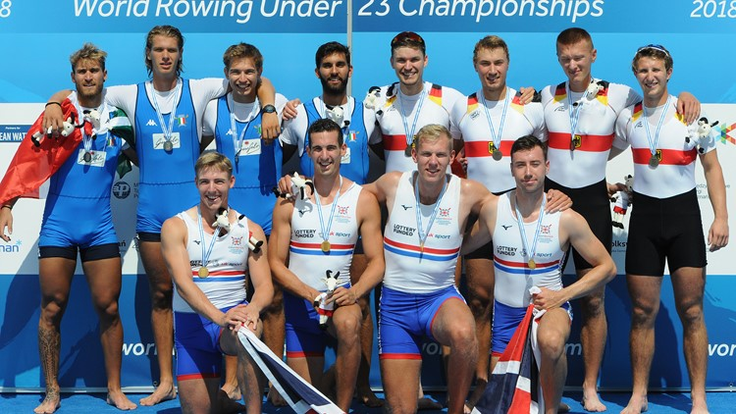
Matt’s crew from Henley Regatta was changed with NRC alumnus Rowan Law coming in at bow and Matt moving to two. They won the final of the quadruple sculls
Official press release follows
The British crew of Meijer, Armstrong, Haywood and Law were having a great regatta and they came through to the final as the favourites following a very fast semi-final yesterday. The British had a great start and they had the early lead with Italy (the winner of the other semi) the closest follower. Great Britain remained in the lead and even got a bit of a margin over Italy who must have been able to see Germany coming. The field remained rather tight and this race was likely to be decided in the third 500.
Great Britain moved clear away from the rest of the field in the third 500 with Italy really having to keep an eye on Germany. These three countries looked to be the medal winners. But what colour? Then Hungary were coming with every stroke. Germany had their work cut out for them. At a 39 stroke rate Great Britain had won. Italy, at 38, grabbed second and Germany held on to third.
Results: GBR, ITA, GER, HUN, UKR, SUI
Rowan Law (b), Great Britain, gold
“That was exactly what we wanted! We’ve been nailing it on the head each race so far. It was about using the experience in the crew. Considering that we have only been together for two and a half weeks, it’s an extremely exciting project. During the race we had no specific pushes and we were able to get ahead at the start to drive on.”
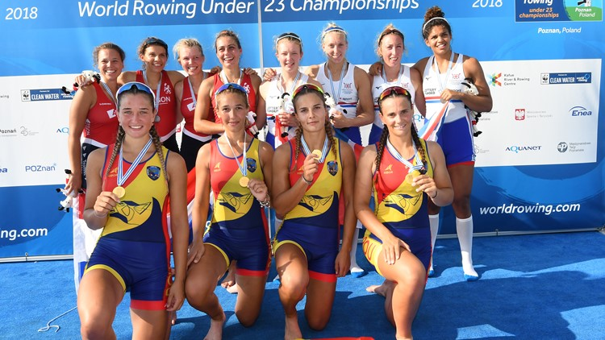
Kyra’s crew contained two of last year’s winning crew, a race she missed due to illness, However, they won a bronze medal in quadruple sculls.
Official press release follows
The heats two days ago saw Romania recording the fastest time and they met winner of the other heat, Great Britain for the first time today. The British are the defending under-23 champions and they have two crew members returning from that boat – Lucy Glover and Saska Budgett. Romania raced at World Rowing Cup II and placed 10th. Romania had the fastest start and they moved through the first 500m mark in the lead. The crew of Radis, Pascanu, Vasile and Logofatu include three members that raced to fourth in this boat class last year. The Netherlands followed in second with Great Britain neck-and-neck in third.
Through the middle of the race the boats remained close with Romania just in front and the British and the Dutch locked tight together. On the shore a fleet of coaches on bikes followed the race. Germany and Canada were back a bit fighting for fourth. The sprint was on and Romania remained ahead of the Dutch-British tussle. Romania had won and they saluted the sky as the Dutch crossed the line in second.
Results: ROU, NED, GBR, GER, CAN, USA
Saska Budgett, Great Britain, bronze
“That was really tough, we went out with a lot of intent but unfortunately that wasn’t enough today. Poznan is really amazing and it’s great to represent Great Britain here and it is great to get a medal, even though not quite the one we wanted.”

Harvey Kay was in the eight that won a silver medal by one thousandth of a second!!

Matt Haywood writes:
I would like to start by thanking you for your continued support and the support of the club throughout this last season it has been invaluable to me.
The season started with competing at senior and U23 final trials in the middle of April, I finished in 13th at these trials with a respectable and competitive time that hopefully next year I can step on and challenge with. After final trials, I took part in the U23 seat racing to be able to earn a seat in a crew boat for the rest of the season. I performed well at this and finished in a strong position.
Seat racing ended with us being selected for a quad for the first event of the season was the Metropolitan Regatta at Eton Dorney. We performed well at this having only been in the boat for a week, we were leading the race the whole way until our bow man caught a crab on the line meaning we lost out to Leander.
Next, we competed at Marlow, where, once again we had a strong race and were leading from the start, we managed to hold on to the lead and won the event against the same strong Leander crew as the Met.
These two events were both leading up to our campaign at Henley, we started the week with a good draw that promised us a good lead into the final. Our first race against the Reading University D crew gave us an easy win as were the following two races against Newcastle and Edinburgh University composite, and the Bayerleverkussen and Essen composite crew from Germany. The final saw us face a very strong crew from the Netherlands who had come second at their National Championships, unfortunately this time we were not victorious and factors did not play in our favour.
After Henley, we were able to get in our full crew for the World Championships, this saw the addition of Rowan Law. We had an incredible Championships ending in a Gold medal in the quadruple sculls. The start of the event was a bit of a mystery for us, as we knew that we were going fast, however we had no clue as to what sort of speed other crews would be hitting. The nerves we were feeling did not go away as we went through the rounds because we still had no idea whether other crews were tactically withholding speed. We won both the heat and the semi-final, and set out for the final with positive minds, wanting to lead from the start, we succeeded with this and as the race unfolded we became more and more confident with our performance. We ended the project with an incredible win which wouldn't have been possible without the support of all the coaches and Nottingham Rowing Club.

Presidents Fund
Nigel Hollingworth won the £100 draw at the annual dinner and Steve Hill won at the City regatta. The Henley Stewards tickets were won by Bob Griffiths.
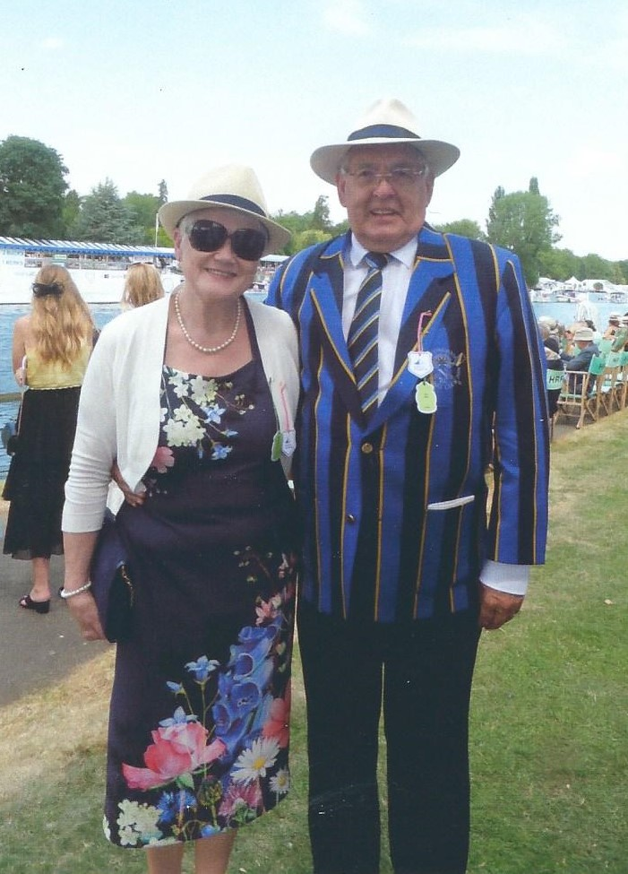
Christine and Bob Griffiths enjoyed their day at Henley Royal Regatta
Accounts
Accounts | to 31 Aug 2018 |  | Total |  | Grants |  | Surplus b/fd
Income | Donations |  | £5,455.42 |  | £5,455.42 |  | £0.00
 | Casc |  | £2,166.61 |  | £2,166.61
 |  |  |  | £7,622.03 |  | £7,622.03 |  | £0.00
Expenditure | Draws | 3 | £310.00 |  | £310.00
 | Grants | 14 | £4,225.00 |  | £4,225.00
 | Food | 2 | £400.00 |  | £400.00
 | Training Camp |  | £4,070.00 |  |  |  | £4,070.00
 | Kettle Weights |  | £1,491.75 |  |  |  | £1,491.75
 |  |  |  | £10,496.75 |  | £4,935.00 |  | £5,561.75
Surplus |  |  |  | -£2,874.72 |  | £2,687.03 |  | £5,561.75
Balance from last year |  |  |  | £5,185.34 |  |  |  | £5,185.34
Balance carried forward |  |  |  | £2,310.62 |  | £2,687.03 |  | -£376.41
President’s Message
We have supported the Home Countries team this year where the club had 11 athletes taking part. We spent last year’s surplus on kettle weights and the Easter training camp for the senior squad. I received a lot of emails thanking me for our support.
Matt had a good year and is on a good trajectory. His future looks bright.
Anna had a fantastic year, particularly for one so young.
Grace continues to win Gold medals despite being injured earlier in the season.
We now boast 5 youngsters at American Universities.
This year’s surplus is buying one of the new RP3 rowing machines. The club is acquiring 8 new RP3 rowing machines which has been financed by private donations. All the serious clubs have these machines. We hope to get them installed before the end of the month.
Thank you all for your support you really do make a difference. Bad news is that this year’s donations are now due.
I could point out that most of the medallists at this year’s championships and the best performances have been Made in Nottingham.
Tony Lorrimer

