Henley Royal Regatta
Presidents Club

Newsletter Flash No 7

HRR
--
Home Countries
--
Scholarships
Nottingham Rowing Club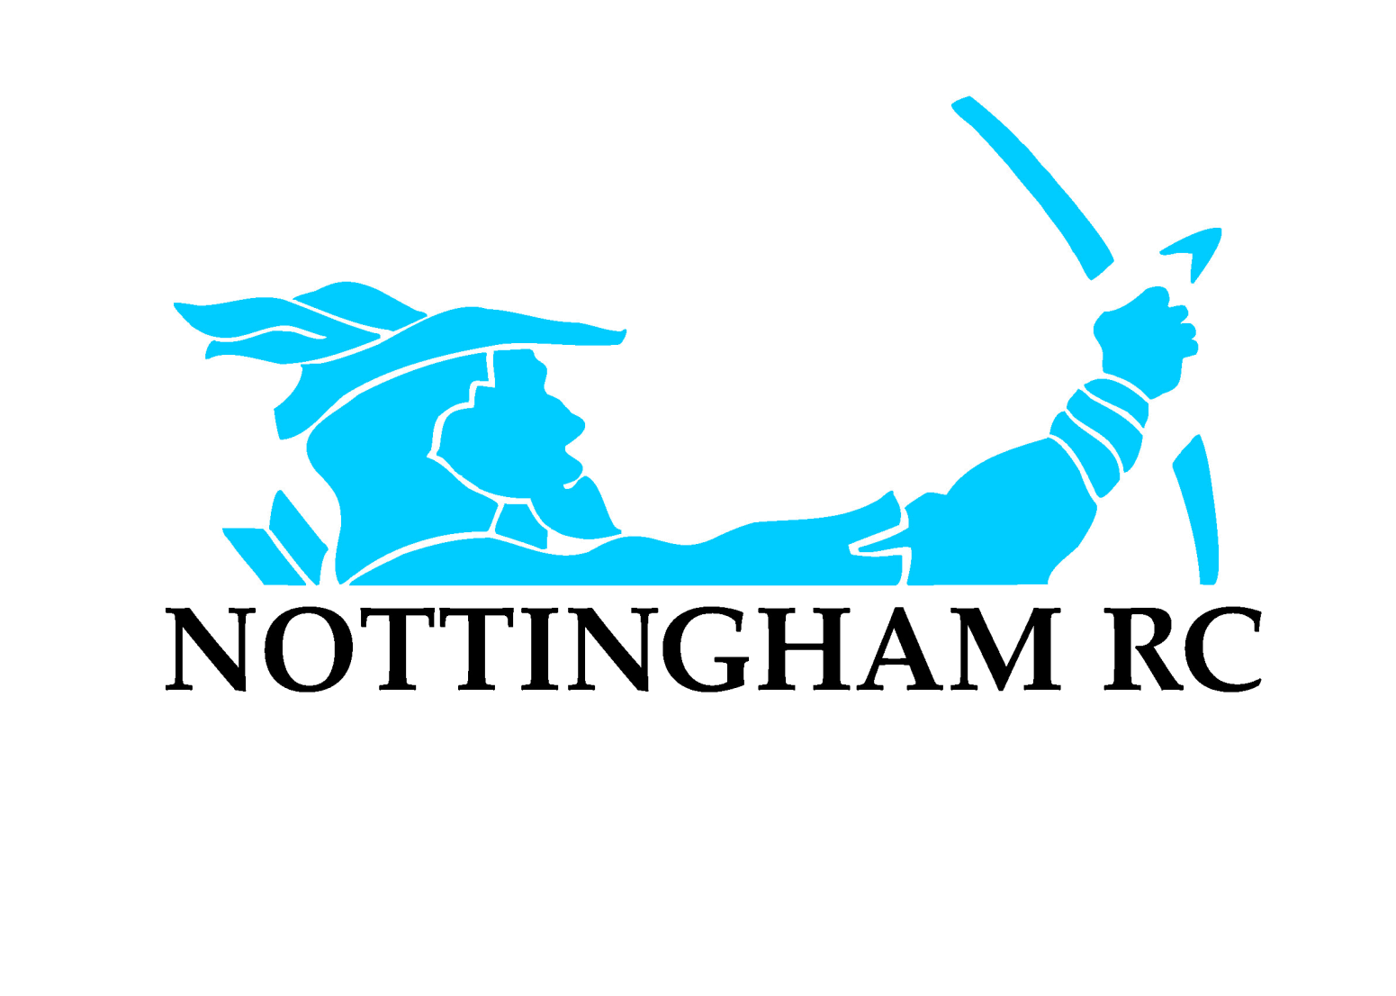

The club took part in the Eliminator races at Henley last weekend. The Club’s second four qualified for the main regatta to join the first four in the Wyfolds Challenge Cup. The first four having qualified due to its wins at Nottingham and Metropolitan Regattas.
The womens double did not make the cut for their event despite having a good scull. It took the Stewards over an hour to release the results suggesting that it was a close call. Annie and Sophie were disappointed.
For Henley week the club is represented by 5 crews in four events.
The first up on Wednesday will be the two Wyfold fours. The first crew has drawn RTHC Bayer Leverkusen from Germany, a seeded crew, of which we know very little. The club crew were training on Trentside on Sunday and looked impressive with a touch of speed. The second four has drawn Walton Rowing Club and is in the same half of the draw as the first four.
On Thursday Matt Haywood’s quadruple scull joins in the fun competing in The Prince of Wales Challenge Cup, they are a seeded crew and should meet Leander in the final where they hope to reserve last year’s result. Rowan Law is in the Leander boat.
On Friday Kyra Edwards having returned from UCLA university for the summer is in the Under 23 Quadruple competing in the Princess Grace Challenge Cup, again this is a seeded crew. Kyra was in the losing crew in last year’s final and would have won a gold medal in the World Under 23 Championships but she had to withdraw from the crew just before the final due to illness.
On Saturday Anna Thornton also having returned from Washington University is competing in the Stoner Challenge Cup with Hodgkins-Byre. They are seeded and the girls have a bye to the semi-final. Anna was in last year’s quadruple that lost the final but she won gold at the Under 23 World championships.
We wish all our representatives the very best of luck.
Home Countries Match/Trial
Sienna Hayes has returned from Cardiff University and is representing Wales. She won the single sculls at Women’s Henley. We have 10 athletes going to the Home countries trials for England. We have Annie Campbell-Orde and Sophie Connoll in the double scull, Max Parker in the single, Rachel Borrows (returning from Bath university) Fleur Tavare, Lucy Holgate and Kate Parsons in the coxed four and Steve Bennett, James Doleman, Harry Mayne and fourth person in the coxless four (Robin can’t do it as he represented Wales last year.)

Scholarships to USA
Two more of our girls have got scholarships to USA. Lucy Holgate is off to Ohio State University, and Jenna Draycott is joining UCLA, where Kyra Edwards is.
Well done them, we wish them every success.

